StyleHub – Fashion Shopping Website
Project: StyleHub | Technology: HTML, CSS, JavaScript (localStorage)

Aim
To develop an online fashion store with categories, search and sort, recommendations, cart, wish list, reviews and order tracking.

Algorithm
- Start: load items, users, orders, carts and wish lists from localStorage.
- Show home page with recommendations (top sold items).
- Search by keyword; sort by price ascending/descending.
- Open item details; add reviews, wish list or cart (quantity limited by stock).
- Checkout: create order, reduce stock, clear cart.
- Orders move Placed → Packed → Shipped → Delivered.
- Admin adds/edits/deletes items and updates order status. Stop.

Result
The StyleHub – Fashion Shopping Website was implemented successfully using HTML, CSS and JavaScript. All modules (login, role-based pages, data entry, search/booking and admin management) work correctly in the browser, and data persists using localStorage.

Implementation (Output Screenshots)
Home page
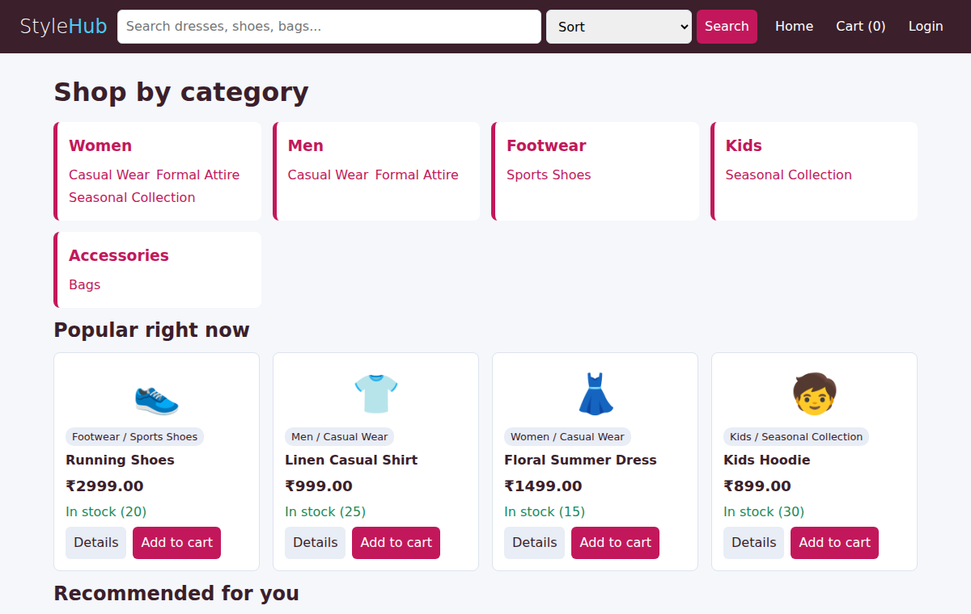
After login (admin / dashboard)
